**While loop in JavaScript**

While loop is an “Entry control loop” that’s means the control arrow enter inside while block (loop) to execute specific statements.

Browser executes the statement(s) inside while block (loop), until the given conditional expression evaluates to false.

Syntax:

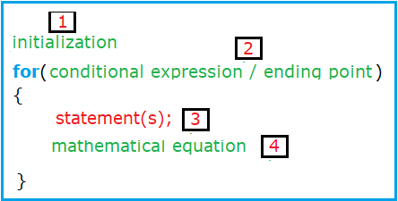

**How while loop keyword works?**

From the previous syntax we can see that while loop keyword consist of 4 parts:

Part 1: Initialization / starting point

Part 2: Conditional expression / ending point

Part 3: Statement also called “while block”

Part 4: Mathematical equation

We will use imaginary arrow to show us the path of execution the code:

The path of this arrow is shown in this picture:

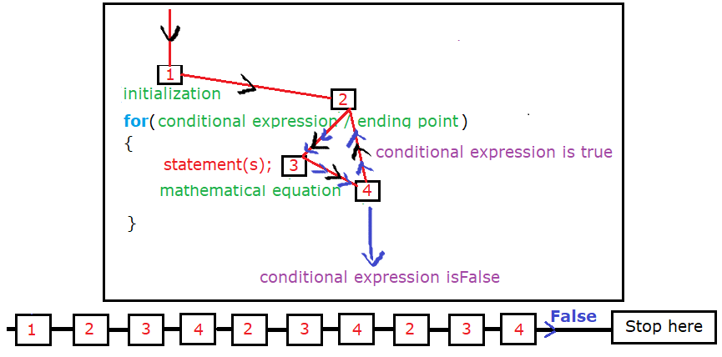

The arrow moves from 1 to 2 to 3 to 4 then to 2 to 3 to 4 to 2……

Because the condition expression is true the arrow will follow this path until the expression condition will be false then **exit** while keyword and go to execute the next down statements.

**Note**:

1. Arrow passes to number1 only one time (when **entering** the for keyword)
2. Loop path is expressed on numbers 2, 3, and 4.
3. What you do with for loop can do with while loop as for and while loop is very similar with slight differences.
4. You can convert for to while and the verse as their syntax is very similar.

**Example1:**

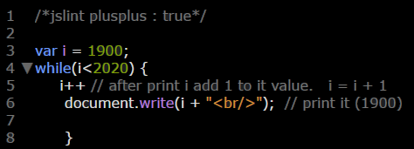

**Example2:**

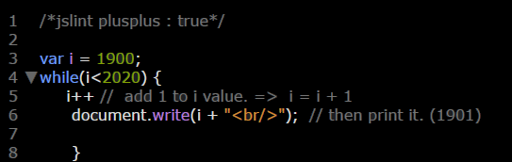

**Example3:**

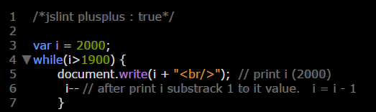

**Example4:**

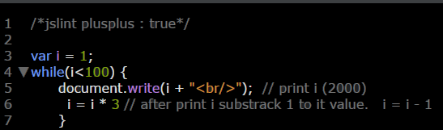

**Example5:**

